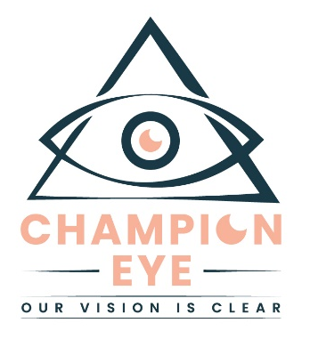
Dear P Dear Patient,

Welcome to Champion Eyecare. A practice started by a group of women who figured there had to be a better way to practice medicine. We wanted to treat patients how we would like to be treated. We wanted to have time to talk to our patients and enjoy the process. We were determined to create a different medical practice.
Each with 10+ years of experience in the field of ophthalmology, we built an eye center where each patient is treated as an individual, and their medical needs tailored as such. We focused on quality, not quantity, and figured the rest would take care of itself.
The response to our vision did not disappoint! Today, we are a thriving group with the same ideals and values. One patient at a time! We are glad you are here, and welcome again to the Champion Eyecare family.
We hope that you find this handout both informative and helpful as you begin your cataract evaluation journey with our team.

Sincerely,
Dr. Champion
Dr. Crofton



What is a Cataract?

A cataract is defined as a clouding of the natural lens of the eye. The lens is approximately the size of an M&M candy and sits just behind the colored iris of your eye. When you are born, the lens is clear; but with time the natural lens becomes clouded and causes blurry vision. A cataract can progress until eventually there is a complete loss of vision in your eye. Cataract surgery can help restore your vision long before you can experience loss of vision that is significant enough to interfere with your daily activities.
During cataract surgery, the clouded natural lens is removed and replaced with a plastic intraocular lens (IOL). The IOL is intended to remain permanently in place and requires no maintenance or handling. The Standard IOLs used in cataract surgery are set for one distance-- their focus is set to provide distance or near vision, but not both. Patients who choose a Standard IOL often still need to wear glasses to achieve the clearest focus for distance and near objects because of their astigmatism and/or presbyopia.

What is Astigmatism? If I have Astigmatism, do I have options for correction?

Astigmatism is characterized by an irregular curvature of the cornea. The eye of a person with astigmatism is shaped more like a football or the back of a spoon. For this person, when light enters the front part of the eye, it is bent more in one direction than the other, causing a blurry, distorted image. About half of the population is born with astigmatism. If you have astigmatism, and you want to see clearly in the distance, you need to wear glasses or contact lenses. There is also the option to receive a Toric IOL, which is an astigmatism-correcting IOL, during cataract surgery. The Toric IOL can correct most of your naturally occurring corneal astigmatism, therefore reducing your dependence on glasses following cataract surgery.
Our practice also offers laser-assisted cataract surgery using the CATALYS® Femtosecond Laser. The laser precisely creates limbal relaxing incisions (LRI) to reduce or eliminate patient's astigmatism, and aides in precise placement of the IOL.

What is Presbyopia? What are my choices?

With time, almost everyone is affected by presbyopia. Presbyopia is caused by the loss of flexibility of the natural lens and the weakening of the lens’s focusing muscle, which causes patients to lose their ability to see up close. It becomes evident to most of us at about age 45 and that’s why we have to start wearing reading glasses or bifocals. Patients who undergo cataract surgery with a monofocal IOL will need to have reading glasses to see up close afterward. Presbyopia is not treated by the standard monofocal IOL. Patients who choose one of these presbyopia correcting IOLs (Multifocal or Extended Focus IOLs) can usually see far away, at intermediate distance, and up close while greatly reducing their need for glasses and possibly eliminating them altogether.

Paying for Your Lenses and the CATALYS® Femtosecond Laser

Depending on the results of your examination, you may have the option to choose a Toric IOL, Extended Focus or a Multifocal IOL, or you may choose a standard monofocal IOL. Regardless of your options, all of the lenses will help you see better, so there is no wrong choice.
Medicare and insurance cover the cost of cataract surgery with a standard monofocal lens. If you would like to take advantage of the advanced lenses and/or CATALYS® Laser, the procedure itself will still be covered, but there will be additional costs. We will be happy to review the options and discuss cost in a private setting.
We thank you for reading this introduction. During your visit you’ll have the opportunity to hear more about these choices to improve your vision. We look forward to your examination and to helping you learn more about these exciting new options.

Thank you for choosing Champion Eye Care for your eye care needs!


Scan QR Code to watch a video about cataract surgery and Femtosecond laser

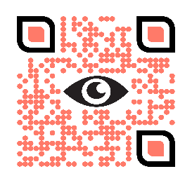

Scan QR Code to visit our main website
www.championeyecare.com

Cataract Consult Questionnaire

Please complete this form and bring with you to your cataract surgery consultation.

Name: ____________________________________________________________

At your cataract surgery consultation, you will have a thorough examination and testing to determine which surgical options are best for you.

To better serve your needs and expectations, please check all that apply:

I have reviewed this Pre-Education Packet about cataract surgery.
Yes No
I watched the video about cataract surgery.
Yes No

Which one of these bests describes you?
I hope to need glasses or contacts as rarely as possible after cataract surgery (has out of pocket costs).
I want sharp distance vision after cataract surgery. I am fine using glasses for up close vision (sometimes has out of pocket cost).
My eyes are naturally focused for up close vision, and I want to maintain that after cataract surgery. I am fine using glasses for distance vision (has no out of pocket cost other than deductibles/copays).
I do not mind using glasses for distance and near vision after cataract surgery (has no out of pocket cost other than deductibles/copays).

